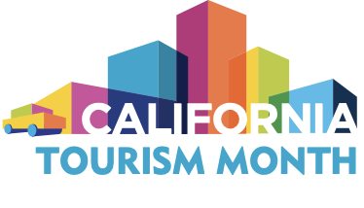

California Tourism Month
Sample Newsletter Article

Adapt this sample article for your newsletters and other online publications. The article conveys key messages and activities to help your organization promote California Tourism Month with your network of stakeholders, legislators and local community.

Optional placeholders are highlighted. Additionally, you may review the talking points provided in the toolkit for additional messaging to communicate the importance of tourism to your audience.

Join ORG NAME in Celebrating California Tourism Month

May is California Tourism Month, the state of California’s official observance of tourism’s essential role in the state’s economy and identity. This year, on the cusp of the state’s June 15 reopening, Visit California and California’s tourism industry are celebrating the Power of Possibility inherent in California travel. The month-long spotlight on our industry is an opportunity to share what’s reopening, what we’ve missed and why travel tourism will help the entire Golden State recover from the pandemic.

While there is good reason for optimism this May, it remains true that the pandemic exacted a painful toll on our industry. During last tourism month, 600,000 tourism workers lost their jobs as California’s economy all but shut down and many remain out of work. No industry suffered more severe job losses. Worse, according to Visit California research from RAND Corp., workers of color, those living in urban areas and those just beginning their careers were especially impacted.

We need all Californians to help the economy recover by keeping their tourism dollars in California and supporting local businesses. The state’s groundwork of sustainable, diverse travel experiences has positioned California to reclaim its place as one of the most desirable destinations in the U.S. and on the planet. An industry that in 2019 employed 1.2 million Californians — about one in 40 — can and will return stronger than before.

There is power and possibility in California civic pride. But we need California’s residents and our political and civic leaders to understand the hurdles that remain. And you can help.

Here’s how:
- Spread the word on social media! Share pro-tourism messages with #CATourism.
- From May 3-9, join in U.S. Travel’s National Tourism Week with an additional #PowerOfTravel tag.
- Travel, shop and dine in state. Don’t forget to post about these experiences with the #CATourism tag!
- Contact your local representatives to let them know that the travel and hospitality industry, particularly its workforce, needs help to help lead California’s economic recovery.

