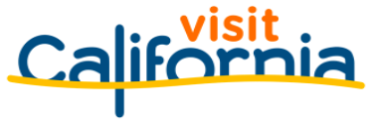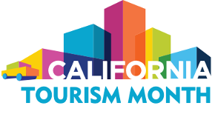
California Tourism Month
Sample Newsletter Article

Adapt the sample article below for your newsletters and online publications to help promote California Tourism Month with your network of stakeholders, legislators and local community. Customize the [highlighted] text below with information from Visit California’s economic impact report that is relevant to your county/region and details specific to your organization.

Reference this year’s Economic Impact Report for local data on travel spending, tax revenue and jobs.

Theme: California’s tourism economy has made significant strides toward recovery over the past two years, yet more work remains to fully restore the tourism economy.

Join ORG NAME in Celebrating California Tourism Month

May is California Tourism Month, the state of California’s official observance of tourism’s essential role in the state’s economy and identity. This year, Visit California and California’s tourism industry are recognizing the great strides the industry has made toward recovery over the past two years amid devastating business closures and job losses.

In [DESTINATION] in particular, visitor spending reached $[XX], providing [XX] jobs in 2021, according to Visit California’s annual economic impact report prepared by Dean Runyan Associates. While the 2021 economic impact numbers marked a significant improvement over 2020, [DESTINATION] remains XX% of the way to reaching the pre-pandemic success of 2019. Only one of California’s 58 counties exceeded the economic impact achieved in 2019.

California tourism’s recovery continues on an uneven path. However, as travel normalizes and travel more visits return to cities and travel further abroad, the current in-state competitive dynamics promise to change.

Statewide, visitor spending reached $100.2 billion in 2021, up 46% from 2020. Employment and visitor-generated tax revenue across the state also rose in 2021.

Still, what visitors spent in California in 2021 amounted to just 69% of the record $144.9 billion reported in 2019. Employment levels in California’s tourism industry remained only about three-fourths of the 1.2 million workers recorded in 2019. International inbound travel and business travel have also been slow to return, disproportionately hurting many of our state’s urban centers and iconic destinations.

California’s tourism economy cannot be made whole until travel spending and employment numbers return to 2019 levels across the state. This California Tourism Month we must help our political and civic leaders understand the importance of cohesively reviving the tourism industry. The unified rebound of travel will drive California’s economy and workforce forward.

Here’s how:
- Spread the word on social media! Share pro-tourism messages with #CATourism.
- From May 1-7, join in U.S. Travel’s National Travel and Tourism Week with an additional #FutureofTravel tag.
- Travel, shop and dine in the state. Your tourism dollars help businesses recover faster. Don’t forget to post about these experiences with the #CATourism tag!
- Contact your local representatives to let them know that the state cannot fully recover until the tourism industry – and the spending, jobs and tax revenue it provides – fully recovers.

