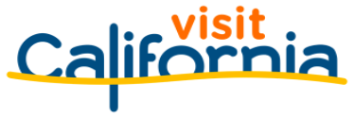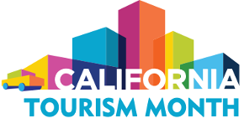
California Tourism Month 2023
Sample Newsletter Article

Adapt the sample article below for your newsletters and online publications to help promote California Tourism Month with your network of stakeholders, legislators and local community. Customize the [highlighted] text below with information from Visit California’s economic impact report that is relevant to your county/region and details specific to your organization.

THEME: CALIFORNIA TOURISM BOUNCES BACK – 93% OF THE WAY BACK TO PRE--PANDEMIC LEVELS.

Join ORG NAME in Celebrating California Tourism Month

May is California Tourism Month, the state of California’s official observance of tourism’s essential role in the state’s economy and identity. This year, Visit California and California’s tourism industry are celebrating the ongoing strength and resilience of California’s travel industry that is poised to set new records for visitor spending, employment and tax generation after the devastating coronavirus pandemic.

In [DESTINATION] in particular, visitor spending reached $[XX], providing [XX] jobs in 2022, according to Visit California’s annual economic impact report prepared by Dean Runyan Associates.

Statewide, visitor spending reached $134.4 billion in 2022. Tourism jobs (1.1 million) and state and local taxes paid by visitors ($11.9 billion) also reached more than 90% of pre- pandemic levels in 2022.

New research from Visit California also shows Californians see tourism as a net positive in their communities. A majority of Californians believe tourism creates a better quality of life in their region and that the benefits of tourism outweigh the problems. More than 70% say tourism generates local business opportunities and provides jobs to local residents. Visit California’s new tourism workforce video series showcases first hand experiences of Californians finding rewarding opportunities in travel.

This California Tourism Month we must showcase the power of travel with our political and civic leaders. A strong tourism industry continues to drive California’s economy and workforce forward.

Here’s how:
- Spread the word on social media! Share pro-tourism messages with #CATourism.
- From May 7-13, join in U.S. Travel’s National Travel and Tourism Week with an additional #TravelForward tag.
- Travel, shop and dine in the state. Your tourism dollars help businesses recover faster. Don’t forget to post about these experiences with the #CATourism tag!
- Contact your local representatives to let them know that the state cannot fully recover until the tourism industry – and the spending, jobs and tax revenue it provides – fully recovers.

