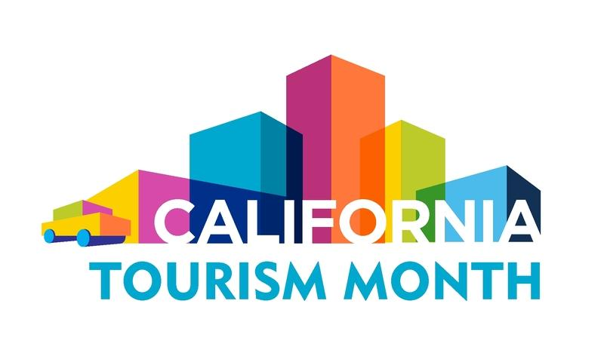
California Tourism Month
Sample Proclamation

Draft a proclamation that declares May 2023 as California Tourism Month in your destination using the sample copy below. Replace any highlighted text with destination/organization specific details and send it to your local city council or mayor. If your elected body issues a proclamation, please notify Visit California Sustainability and Public Affairs Manager Dan Smith at dsmith@visitcalifornia.com.

WHEREAS, Tourism plays a critical role in [DESTINATION] and the state’s economic prosperity; and

WHEREAS, A robust travel industry provides significant economic benefits for the entire state, generating more than $134.7 billion dollars in visitor spending in 2022; and

WHEREAS, Travel has been the foundation of a healthy workforce, serving as one of the largest private-sector employers in California, supporting 1.1 million jobs in 2022; and

WHEREAS, Spending by travelers benefits state and local governments alike, generating $11.9 billion dollars in tax revenue in 2022 to support essential public services and programs that benefit all Californians; and

WHEREAS, In XXXX County, Tourism generated $XXX in visitor spending, $XXX in state and local tax revenue and XXX jobs in 2022; and

WHEREAS, The COVID-19 pandemic devastated every sector of the travel industry with staggering economic impacts, affecting every community in California, including [DESTINATION]; and

WHEREAS, California’s tourism industry’s resilience has brought the economic impact of travel more than 90 percent back to pre-pandemic levels in 2022; and

WHEREAS, The rebound of travel will continue to drive the rebuilding of California’s economy and workforce; and
WHEREAS, The California Legislature in 2016 declared every May as California Tourism Month to celebrate the positive economic impact of the tourism in California; and

WHEREAS, Californians can help put their fellow Californians back to work and support the recovery of local businesses by traveling in California; now,

Therefore, I, [OFFICIAL OR ENTITY’S NAME], do hereby proclaim May 2023 as Tourism Month in [DESTINATION], and urge the residents of [DESTINATION] to join me in recognizing the critical role this industry plays in [DESTINATION].

