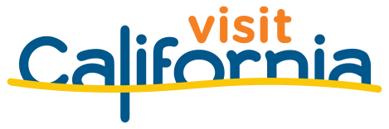

California Tourism Month 2022
Sample Social Media Posts

Use these sample social posts as inspiration for content throughout the month of May to amplify the importance of travel and tourism to the state of California.

HOW TO SHARE CALIFORNIA TOURISM MONTH ON SOCIAL MEDIA
- Customize posts to be consistent with your organization’s voice.
- Post the text below with one of the social media graphics in the toolkit to deliver a strong message to your followers.
- Use the hashtag #CATourism to show your support.
- Tag your local officials in posts to ensure they are seeing the importance of tourism.

KEY DATES TO POST ON SOCIAL MEDIA
- Monday, May 2: Join U.S. Travel’s Turn Twitter RED for National Travel and
Tourism Week

Download the US Travel Toolkit

- Every Tuesday: Use hashtag #TourismTuesday to share facts about the
importance of tourism to your business, community

FOLLOW VISIT CALIFORNIA NEWS ON SOCIAL MEDIA
- Twitter: @VisitCANews
- Facebook: https://www.facebook.com/CTTCNews
- LinkedIn: https://www.linkedin.com/company/cttcnews/

Sample Posts

#CATourism benefits ALL Californians and strengthens local economies throughout the state: travelmattersca.com.

There is power in California civic pride and together Californians can support the economic recovery of California cities: travelmattersca.com #CATourism.

California can roar back from economic crisis with #CATourism as its engine. Learn more at travelmattersca.com.

May is California Tourism month and this industry would not be possible without #CATourism workers up and down the state. Learn more at travelmattersca.com.

#CATourism keeps jobs in California. This year tourism brought ____ new jobs to ____.

How does #CATourism impact you? Tourism brings $[INSERT VISITOR SPENDING FIGURE] in to [INSERT DESTINATION] every year.

#CATourism is a key economic driver. Bringing travelers back to California will help facilitate recovery in our industry.

This month, join tourism professionals in celebrating what makes #CATourism so important and how we’re accelerating California’s tourism recovery.

#CATourism is coming back! Visitor spending reached $100.2 billion in 2021, up 46% from 2020. Employment and visitor-generated tax revenue also rose last year.

