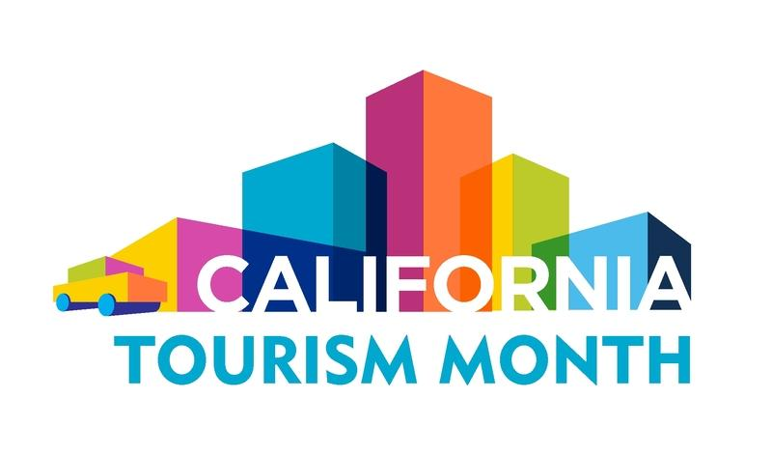
California Tourism Month
Sample Proclamation

Draft a proclamation that declares May 2022 as California Tourism Month in your destination using the sample copy below. Replace any highlighted text with destination/organization specific details and send it to your local city council or mayor. If your elected body issues a proclamation, please notify Visit California Sustainability and Public Affairs Manager Dan Smith at dsmith@visitcalifornia.com.

WHEREAS, Tourism plays a critical role in [DESTINATION] and the state’s economic prosperity; and

WHEREAS, A robust travel industry provides significant economic benefits for the entire state, generating more than $144 billion dollars in visitor spending in 2019; and

WHEREAS, Travel has been the foundation of a healthy workforce, serving as one of the largest private-sector employers in California, supporting 1.2 million jobs in 2019; and

WHEREAS, Spending by travelers benefits state and local governments alike, generating $12.2 billion dollars in tax revenue in 2019 to support essential public services and programs that benefit all Californians; and

WHEREAS, The COVID-19 pandemic devastated every sector of the travel industry with staggering economic impacts, affecting every community in California, including [DESTINATION]; and

WHEREAS, California lost $79.8 billion dollars in visitor spending in 2020, a 55-percent decline from the previous year, and lost $6.1 billion dollars in local and state revenues, a 50-percent drop; and

WHEREAS, Nearly one million Californians working in travel and hospitality lost their jobs in the first month of the pandemic, and the employment sector remains by far the hardest hit in California; and

WHEREAS, [INSERT DESTINATION DATA ON 2020 LOSS OF TRAVEL-GENERATED SPENDING, TAX RECEIPTS, EMPLOYMENT].

WHEREAS, The statewide tourism sector began its recovery in 2021 but remains well short of 2019 levels in employment, visitor spending, and taxes generated; and
WHEREAS, [INSERT DESTINATION DATA ON ANNUAL TRAVEL-GENERATED SPENDING, TAX RECEIPTS, EMPLOYMENT]; and

WHEREAS, The travel industry cannot fully recover without the full return of leisure and business travel, as well as meetings and events, by both domestic and international visitors; and
WHEREAS, The rebound of travel will drive the rebuilding of California’s economy and workforce; and
WHEREAS, The California Legislature in 2016 declared every May as California Tourism Month to celebrate the positive economic impact of the tourism in California; and

WHEREAS, Californians can help put their fellow Californians back to work and support the recovery of local businesses by traveling in California; now,

Therefore, I, [OFFICIAL OR ENTITY’S NAME], do hereby proclaim May 2022 as Tourism Month in [DESTINATION], and urge the residents of [DESTINATION] to join me in recognizing the critical role this industry plays in [DESTINATION].

